FULL CI/CD pipeline

Chapter 7

Orchestration

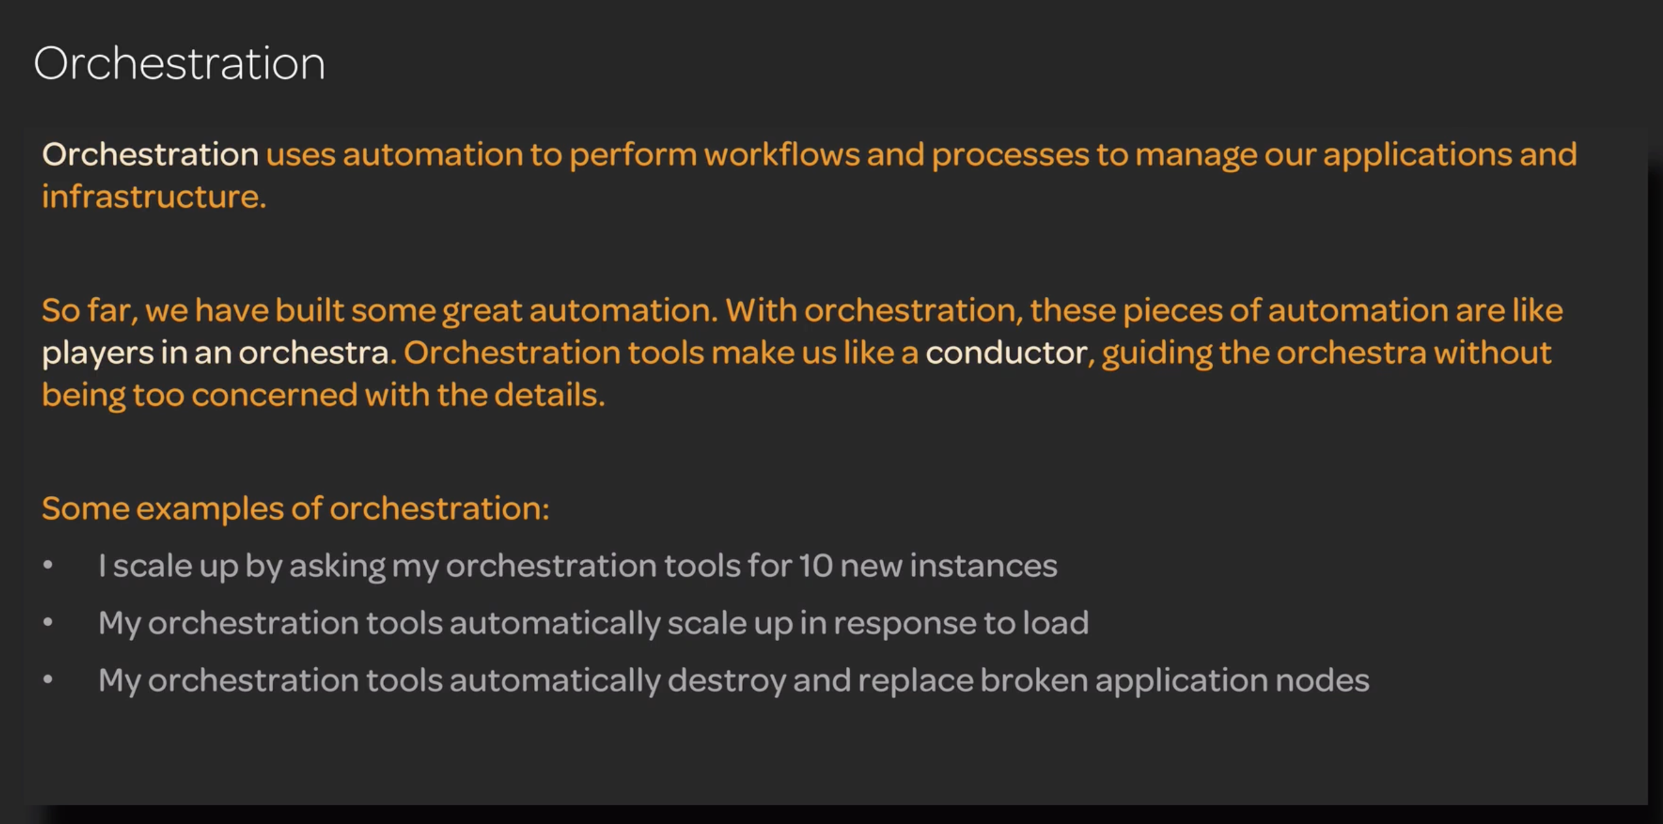

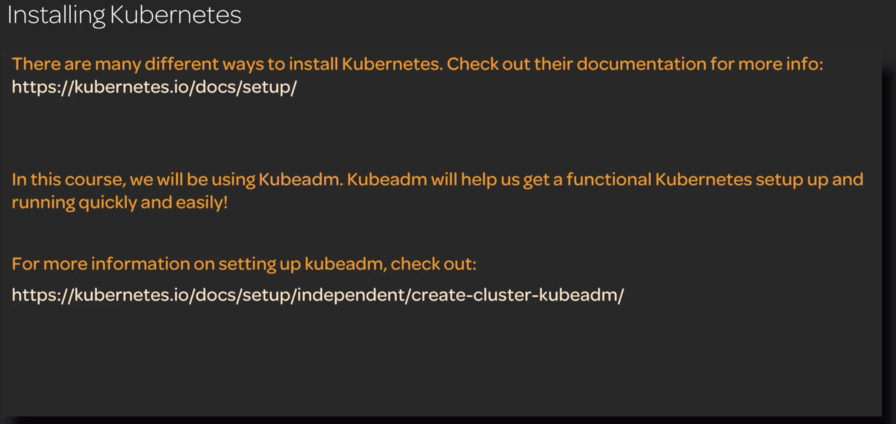

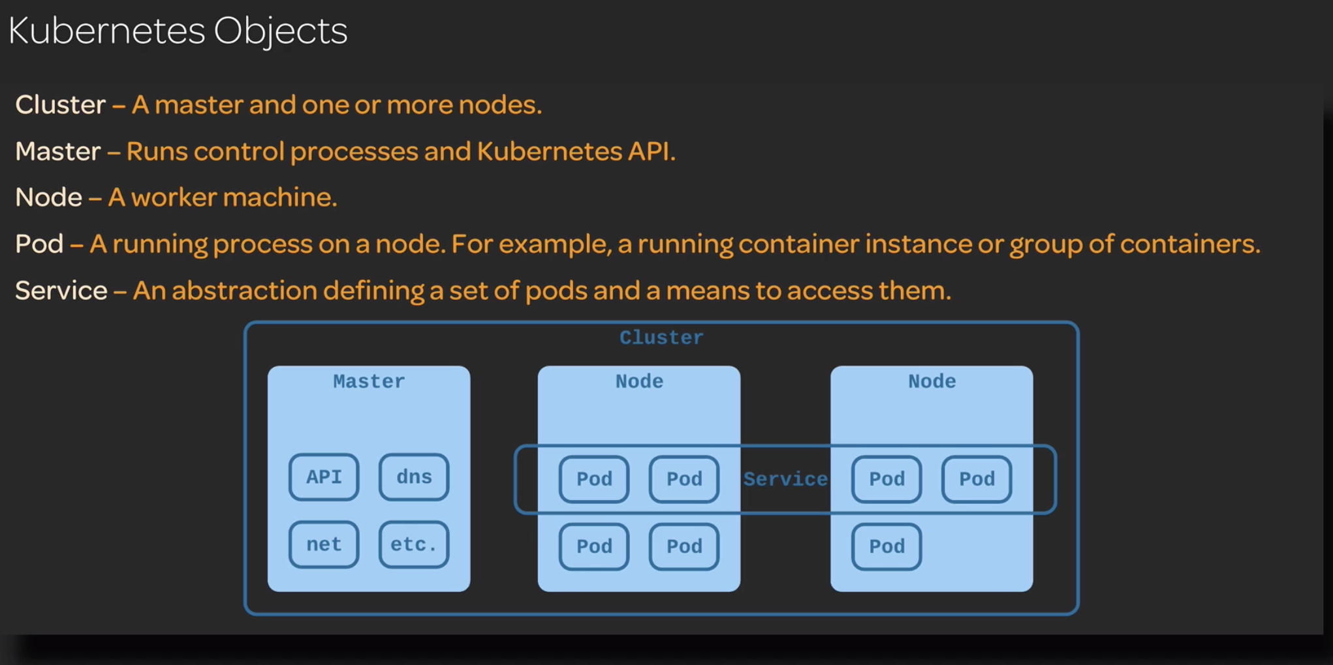

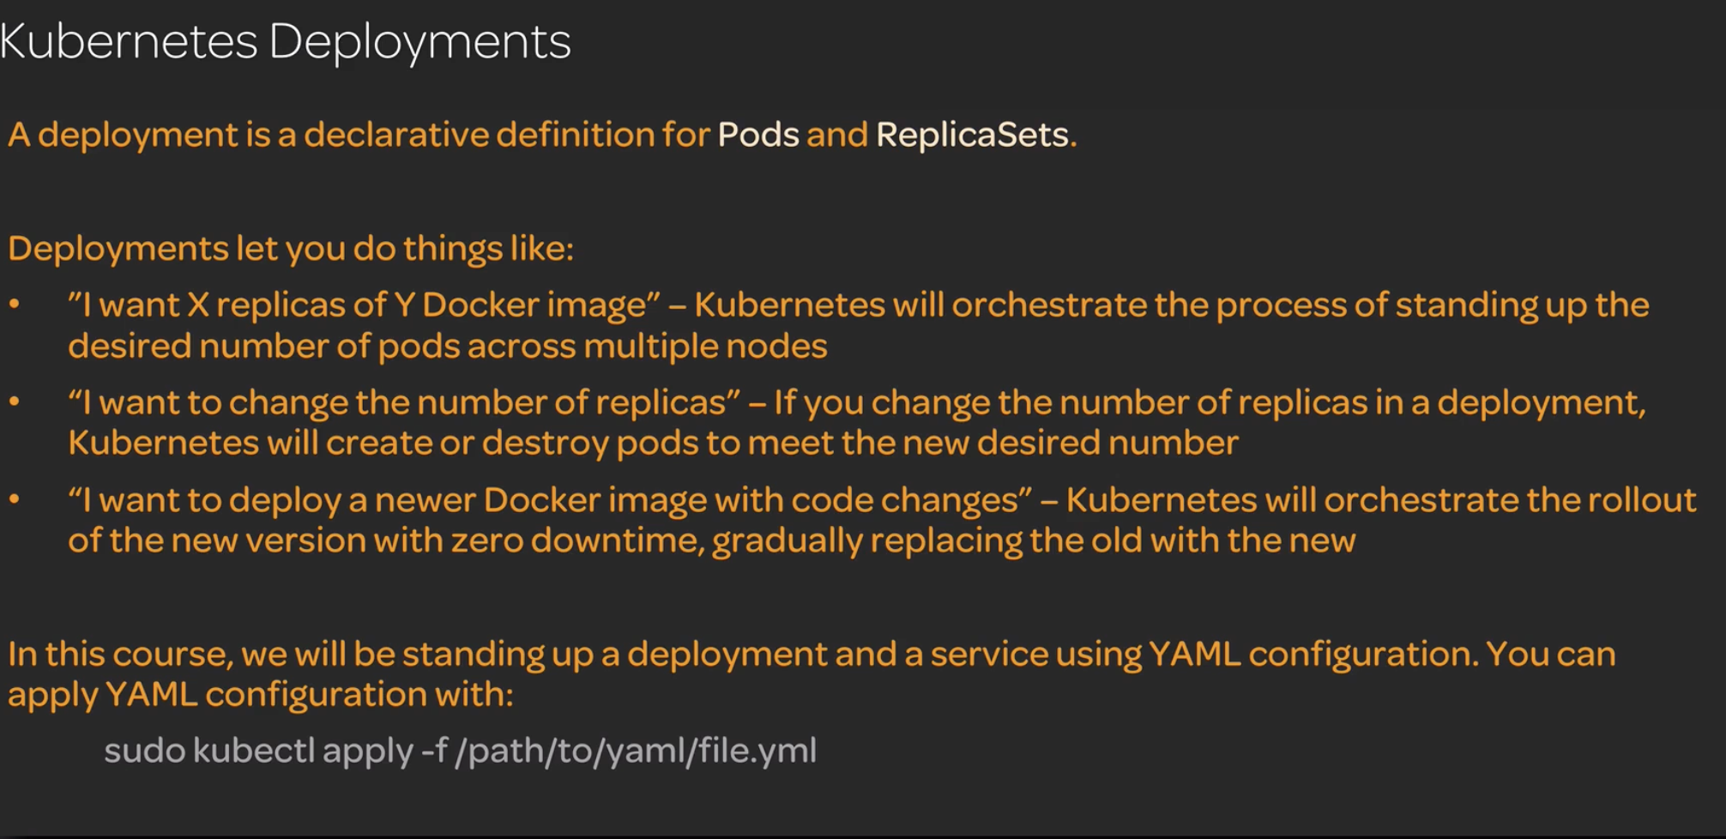

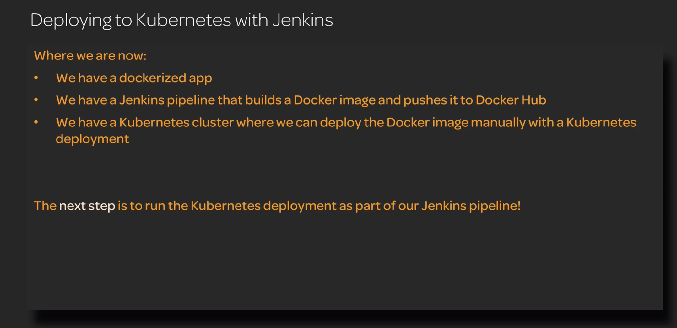

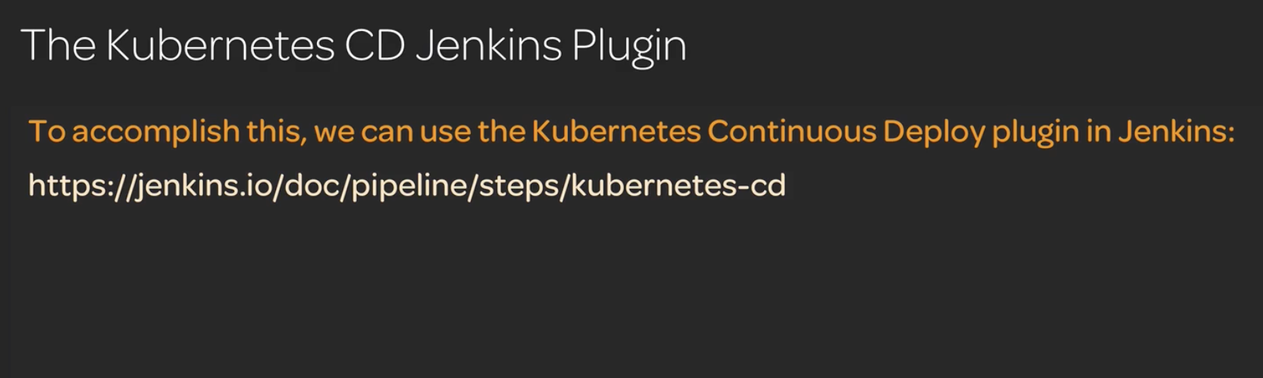

This plugin is no more available to use so implemented above project using ssh-agent plugin

Where I copied the service and deployment yaml file from Jenkins to Kubernetes cluster using scp

To achieve this I need to create a ssh-keygen in Jenkins server

>add the id_rsa.pub to Kubernetes master ./ssh/authorized_keys

>use the Jenkins server private key and create a global credentials using

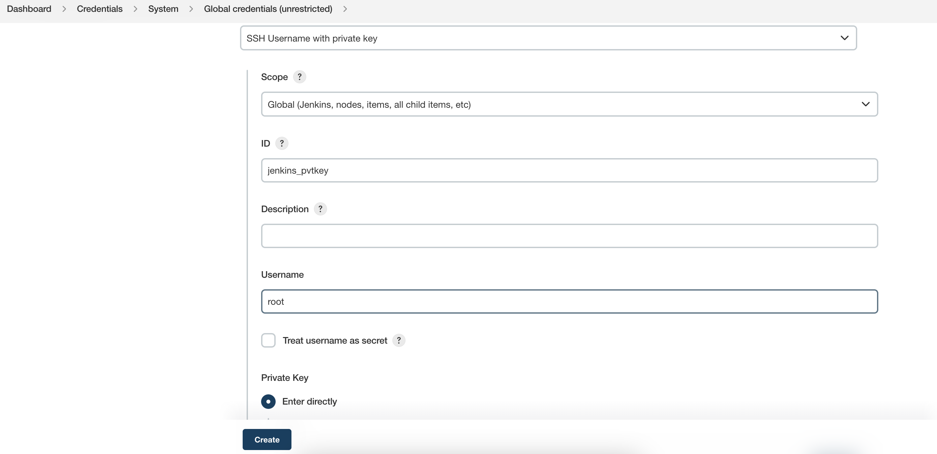

>Use ssh agent plugin to generate pipeline syntax

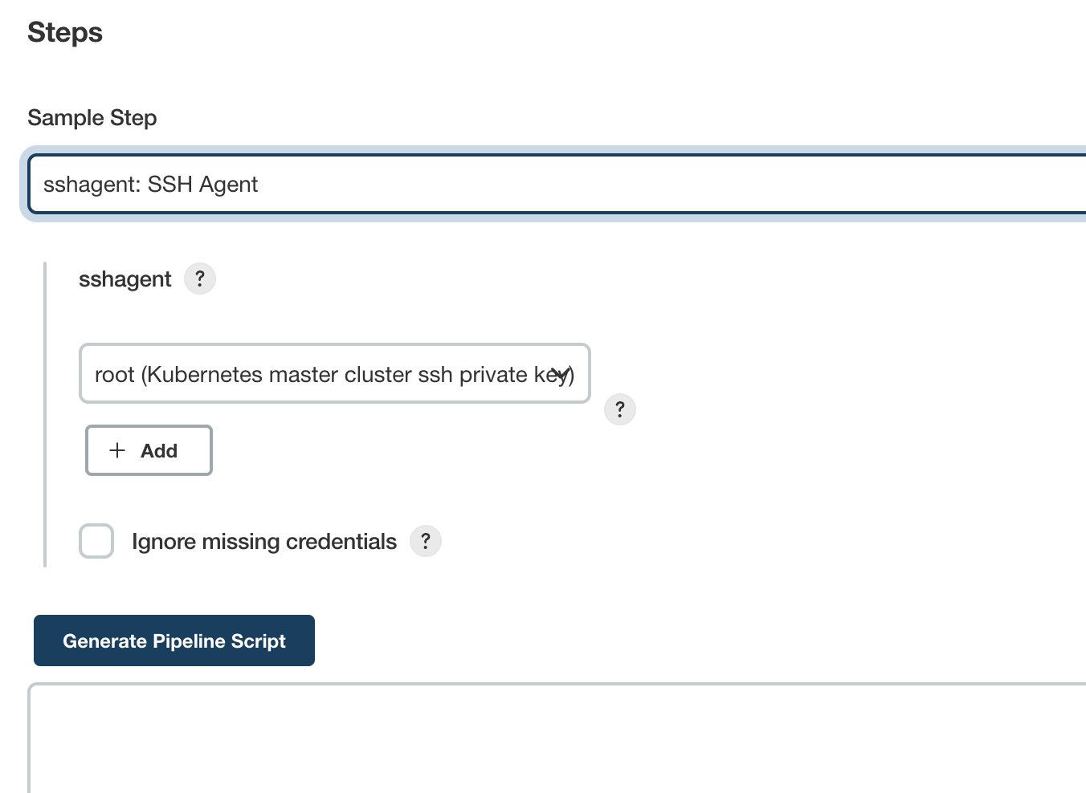

><https://www.youtube.com/watch?v=naUhXrV_rRA>

> <https://www.youtube.com/watch?v=X7bg3JVsGIw>

Versioning can also be implemented writing a bash file

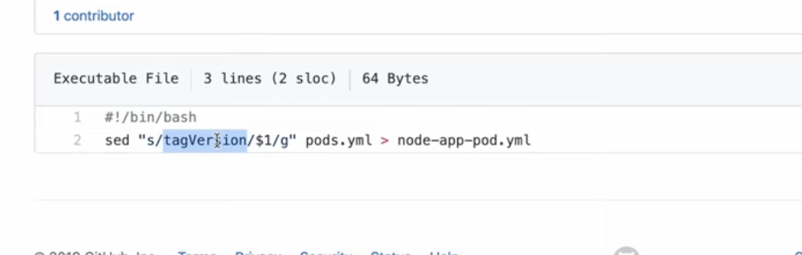

changeTag.sh is the shell file written

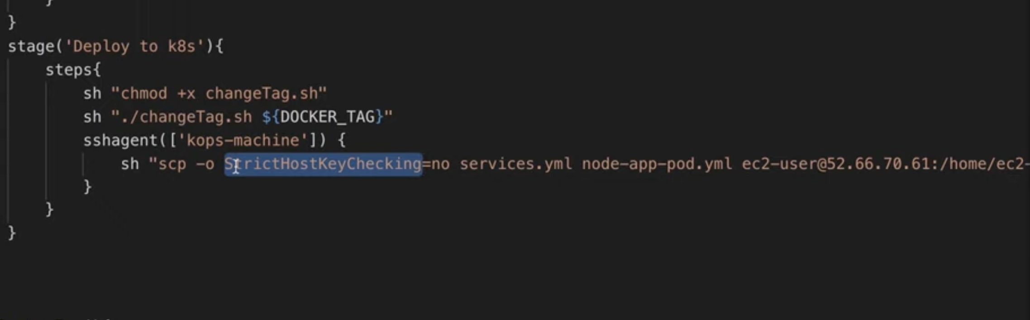

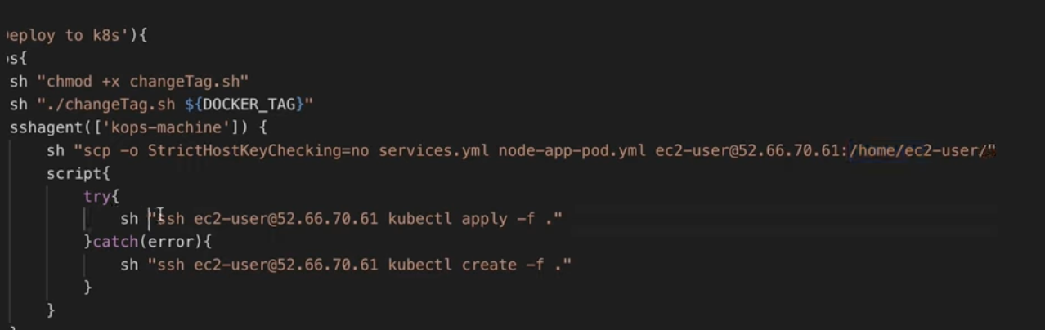

/Users/dheeraj/Desktop/Projects/Class Notes/Devops Notes/Kubernetes/yaml files/k8-train-deployment-service.yml -🡪 resources yaml file

/Users/dheeraj/Desktop/Projects/Class Notes/Devops Notes/Jenkins/Pipeline/kubernetes jenkins deployment -🡪 Jenkins whole pipeline

Enable the 32210 port on security groups which is the NodePort

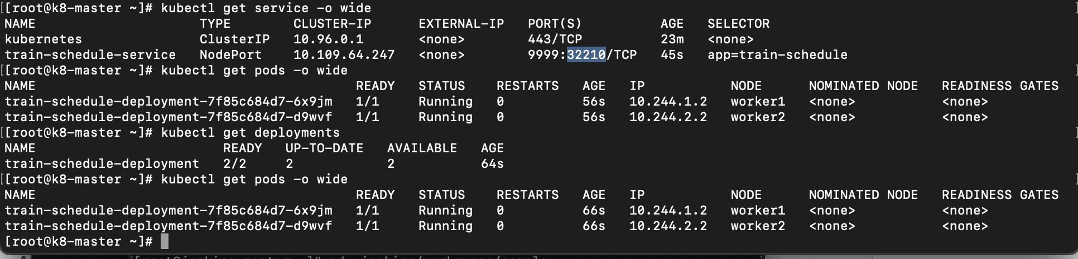

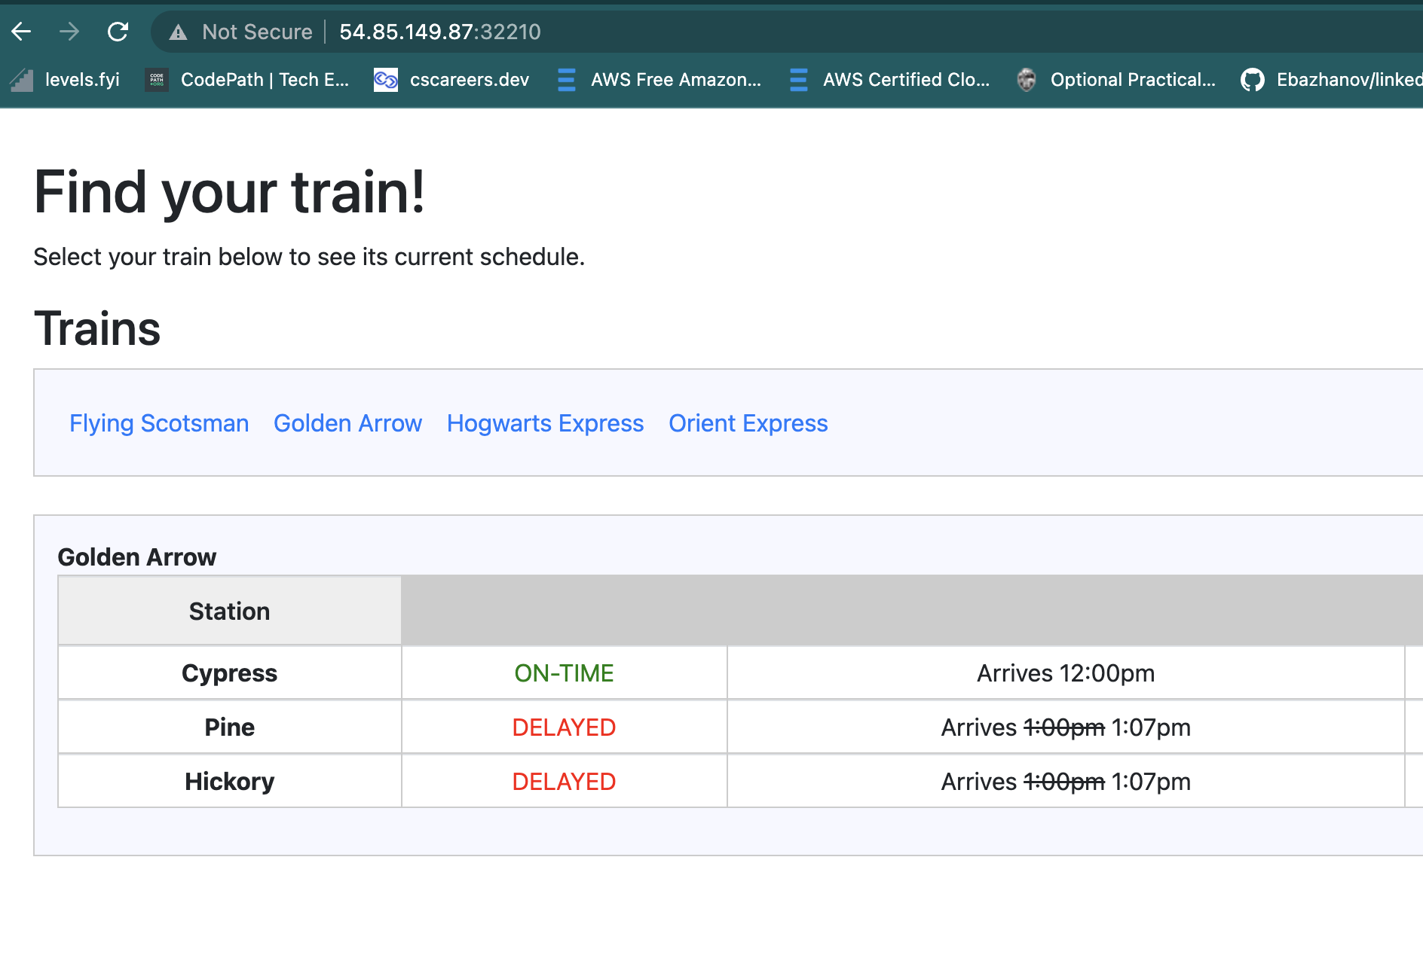

CHAPTER 8

MONITORING

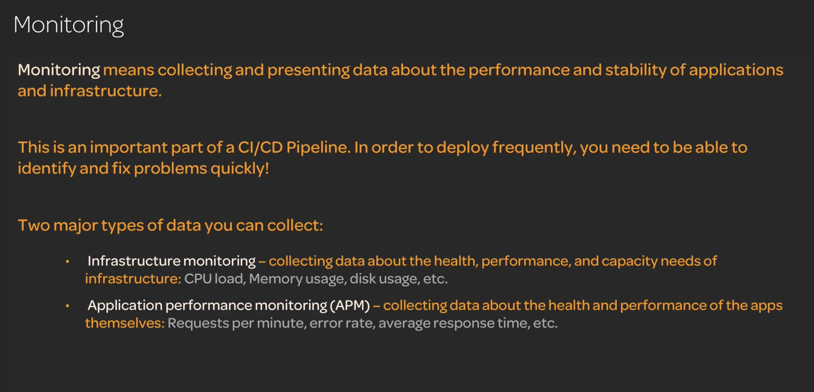

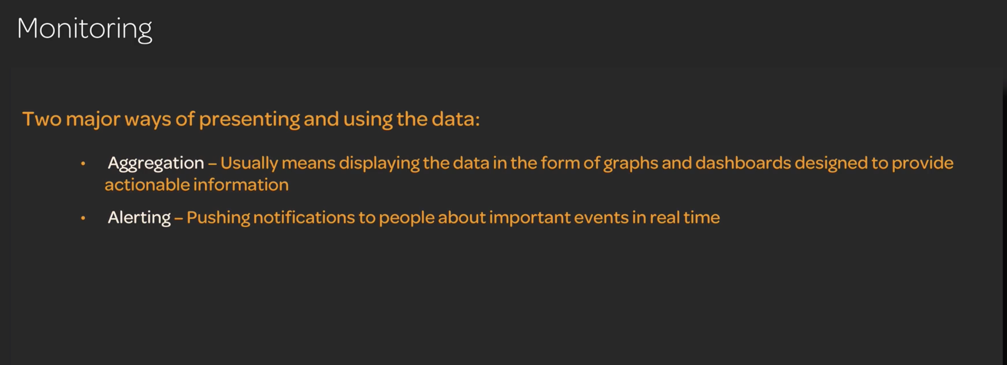

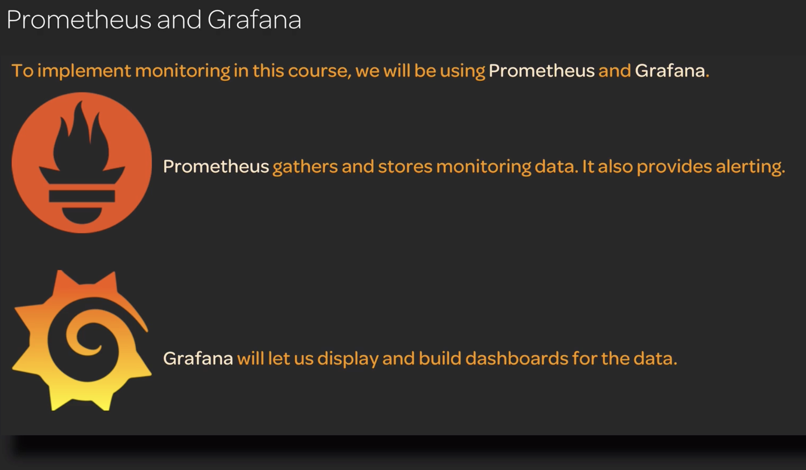

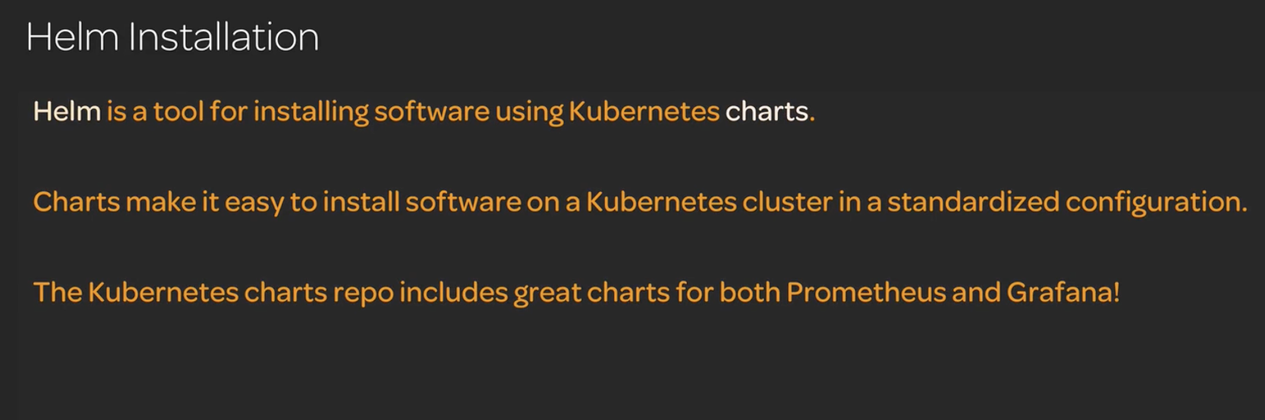

Helm to install pre configured Prometheus and pre configured Grafana

